Dear friends and alumni of the TLL,

We are organizing our first Latin Lexicography Workshop this summer and would be grateful if you can pass on this announcement to your department, colleagues, graduate students, and to any other interested parties. We encourage anyone to participate, including senior scholars. It is an opportunity to share the resources here with a wider public, disseminate practical knowledge about using the TLL, and invite collaboration and discussion from different disciplinary perspectives.

More information on our website and in the announcement below.

<http://www.thesaurus.badw.de/workshop/>

With best wishes,

Adam

**Latin Lexicography Summer Workshop: 30 July – 4 August, 2018**

*Thesaurus linguae Latinae* Institute

Bavarian Academy of Sciences and Humanities, Munich

                The *Thesaurus linguae Latinae* Institute announces its first annual Latin Lexicography Workshop, a one-week event in Munich, July 30 to August 4, 2018. We invite participation by researchers at any stage in their career whose work involves the rigorous evaluation of Latin words in any aspect, ranging from their use in specific texts or their changing significance across the entire corpus of ancient Latin. In addition to philology, relevant disciplines include conceptual and intellectual history, epigraphy, linguistics, literary and textual criticism, medieval and Renaissance studies, philosophy, and theology.

                Each day will be divided between two types of activity. First, seminars and related exercises will address Latin lexicography, the methods and format of the *TLL*, and particularly challenging corpora (e.g. inscriptions, *vetus Latina*, medical and legal sources, ancient lexicography). Secondly, time will be given for participants’ own research in the *Thesaurus* Archive, supported by collaboration with editors and research fellows at the dictionary. The ultimate goal is to provide a supportive environment for participants to develop their own, independent research, while drawing on sophisticated lexicographic techniques and the unique resources of the *Thesaurus* library and Archive.

                The *Thesaurus linguae Latinae* Institute is home to the world’s most comprehensive record of the Latin language (ca. 600 BC to AD 600), consisting of over ten million hand-written notecards, and a world-class library of editions, commentaries, and relevant reference material. Many of these texts have been annotated by former owners and specialists (e.g. Eduard Fraenkel, Wilhelm Heraeus, Friedrich Leo, Eduard Norden, Eduard Wölfflin). These texts also have systematic cross-references to recent discussions of individual words in scholarly journals and other publications. In addition, the Archive contains all the unpublished material for the *TLL* Onomasticon, consisting of all proper names and their derivatives (e.g. *Homerus,* *palatium*). The Bavarian Academy also houses the German *Mittellateinisches Wörterbuch*, with an extensive library of medieval texts, and is walking distance from the Bayerische Staatsbibliothek, which has an outstanding Latin manuscript collection, as well as the excellent libraries of the Institut für Klassische Philologie at Ludwig-Maximilians-Universität and the Kommission für Alte Geschichte und Epigraphik at the Deutsches Archäologisches Institut.

**Practicalities**

                The workshop begins at 9:30 am on July 30. Daily activities will typically run from 9:30 until 5pm over the course of the week, with some optional excursions. Participants are responsible for their own housing; occasional refreshments will be provided. The language of group instruction is English, but one-on-one support is available in several languages (Dutch, French, German, Italian, Spanish). A Certificate of Participation is available upon submission of a short report on your research findings, which will be stored in the Archive for future researchers to consult.

**Application**

                Applications must be received by June 1 by email to [workshop@thesaurus.badw.de](mailto:workshop@thesaurus.badw.de). Applications should include a *curriculum vitae* and a one- to two-page Statement of Benefit. The Statement should briefly describe one or more words that you plan to investigate (whether or not they have been published in the *TLL*), why they are important for your research, and what questions you hope to address during your stay. Demonstrating familiarity with existing lexicographic resources is recommended. The number of participants is limited, and successful applicants will be notified by June 15.

**Summary**

Application due: June 1

Participation fee: €70

Location: Bayerische Akademie der Wissenschaften, Alfons-Goppel-Str. 11, 80539, Munich, Germany

Contact: [workshop@thesaurus.badw.de](mailto:workshop@thesaurus.badw.de)

<http://www.thesaurus.badw.de/workshop/>

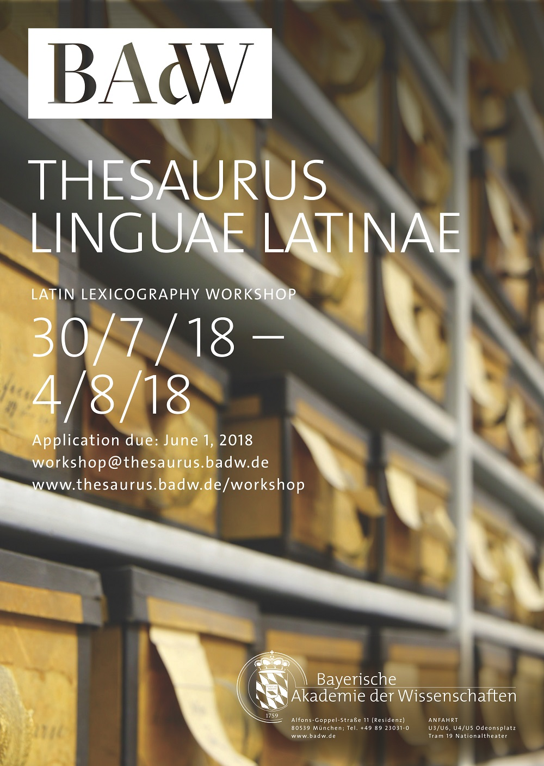

--

Dr. Adam Gitner

*Thesaurus linguae Latinae*

Bayerische Akademie der Wissenschaften

Alfons-Goppel-Straße 11

80539 München